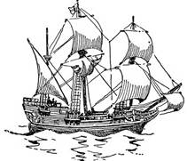

Mayflower Juniors
share this book
mark with you.

“All great and honorable actions are accompanied
with great difficulties, and both must be enterprised
and overcome with
answerable courage.”
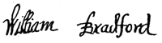

Mayflower Juniors
share this book
mark with you.

“All great and honorable actions are accompanied
with great difficulties, and both must be enterprised
and overcome with
answerable courage.”

Mayflower Juniors
share this book
mark with you.

“All great and honorable actions are accompanied
with great difficulties, and both must be enterprised
and overcome with
answerable courage.”

Mayflower Juniors
share this book
mark with you.

“All great and honorable actions are accompanied
with great difficulties, and both must be enterprised
and overcome with
answerable courage.”

Mayflower Juniors
share this book
mark with you.

“All great and honorable actions are accompanied
with great difficulties, and
both must be enterprised
and overcome with
answerable courage.”

Mayflower Juniors
share this book
mark with you.

“All great and honorable actions are accompanied
with great difficulties, and both must be enterprised
and overcome with
answerable courage.”

